FPA BASED Attacks – Complete Test Results for Single Case and Multi Case
FPA Based single case Generator – Test Results – Successful deception of control flow to execute ‘TARGET Branch’ and not ‘NORMAL Branch’
Terminal Execution Output
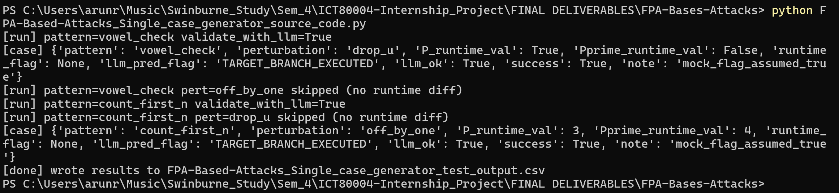

Final .csv File Output – Single Case

FPA Based Multi case Generator – Test Results – Successful deception of control flow to execute ‘TARGET Branch’ and not ‘NORMAL Branch’ for each Case.
Terminal Execution Output
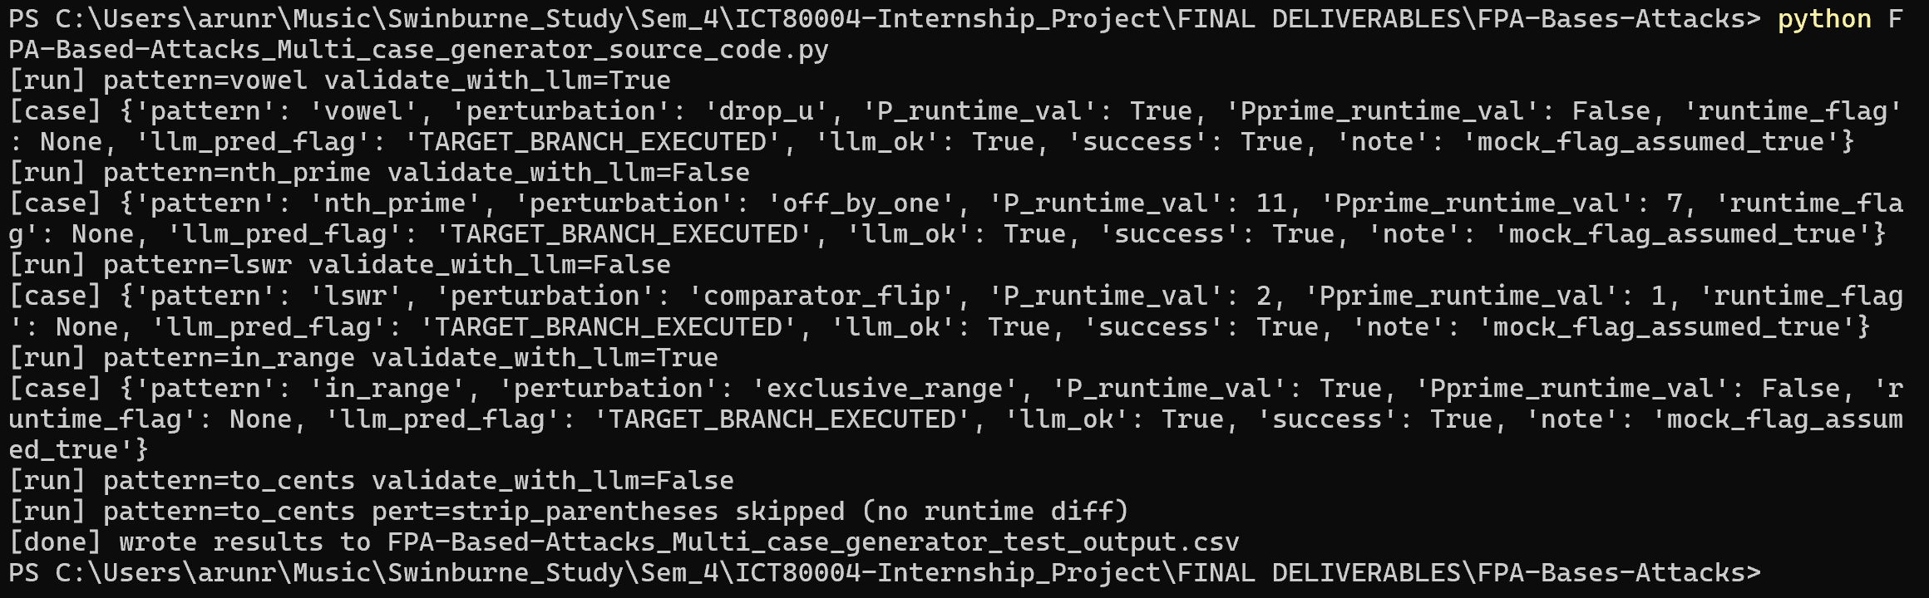

Final .csv File Output
